**1. Introduction.**

**1.1 Overview**

This project documentation outlines the process of designing a visually appealing certificate for a debate competition.

**1.2 Purpose**

The purpose of this project is to create a certificate that not only acknowledges participants but also enhances the overall experience of the debate competition.

**2. Problem Definition & Design Thinking**

In this section, we will define the problem and explore the design thinking process that guided the certificate creation.

**2.1 EMPATHY MAP**

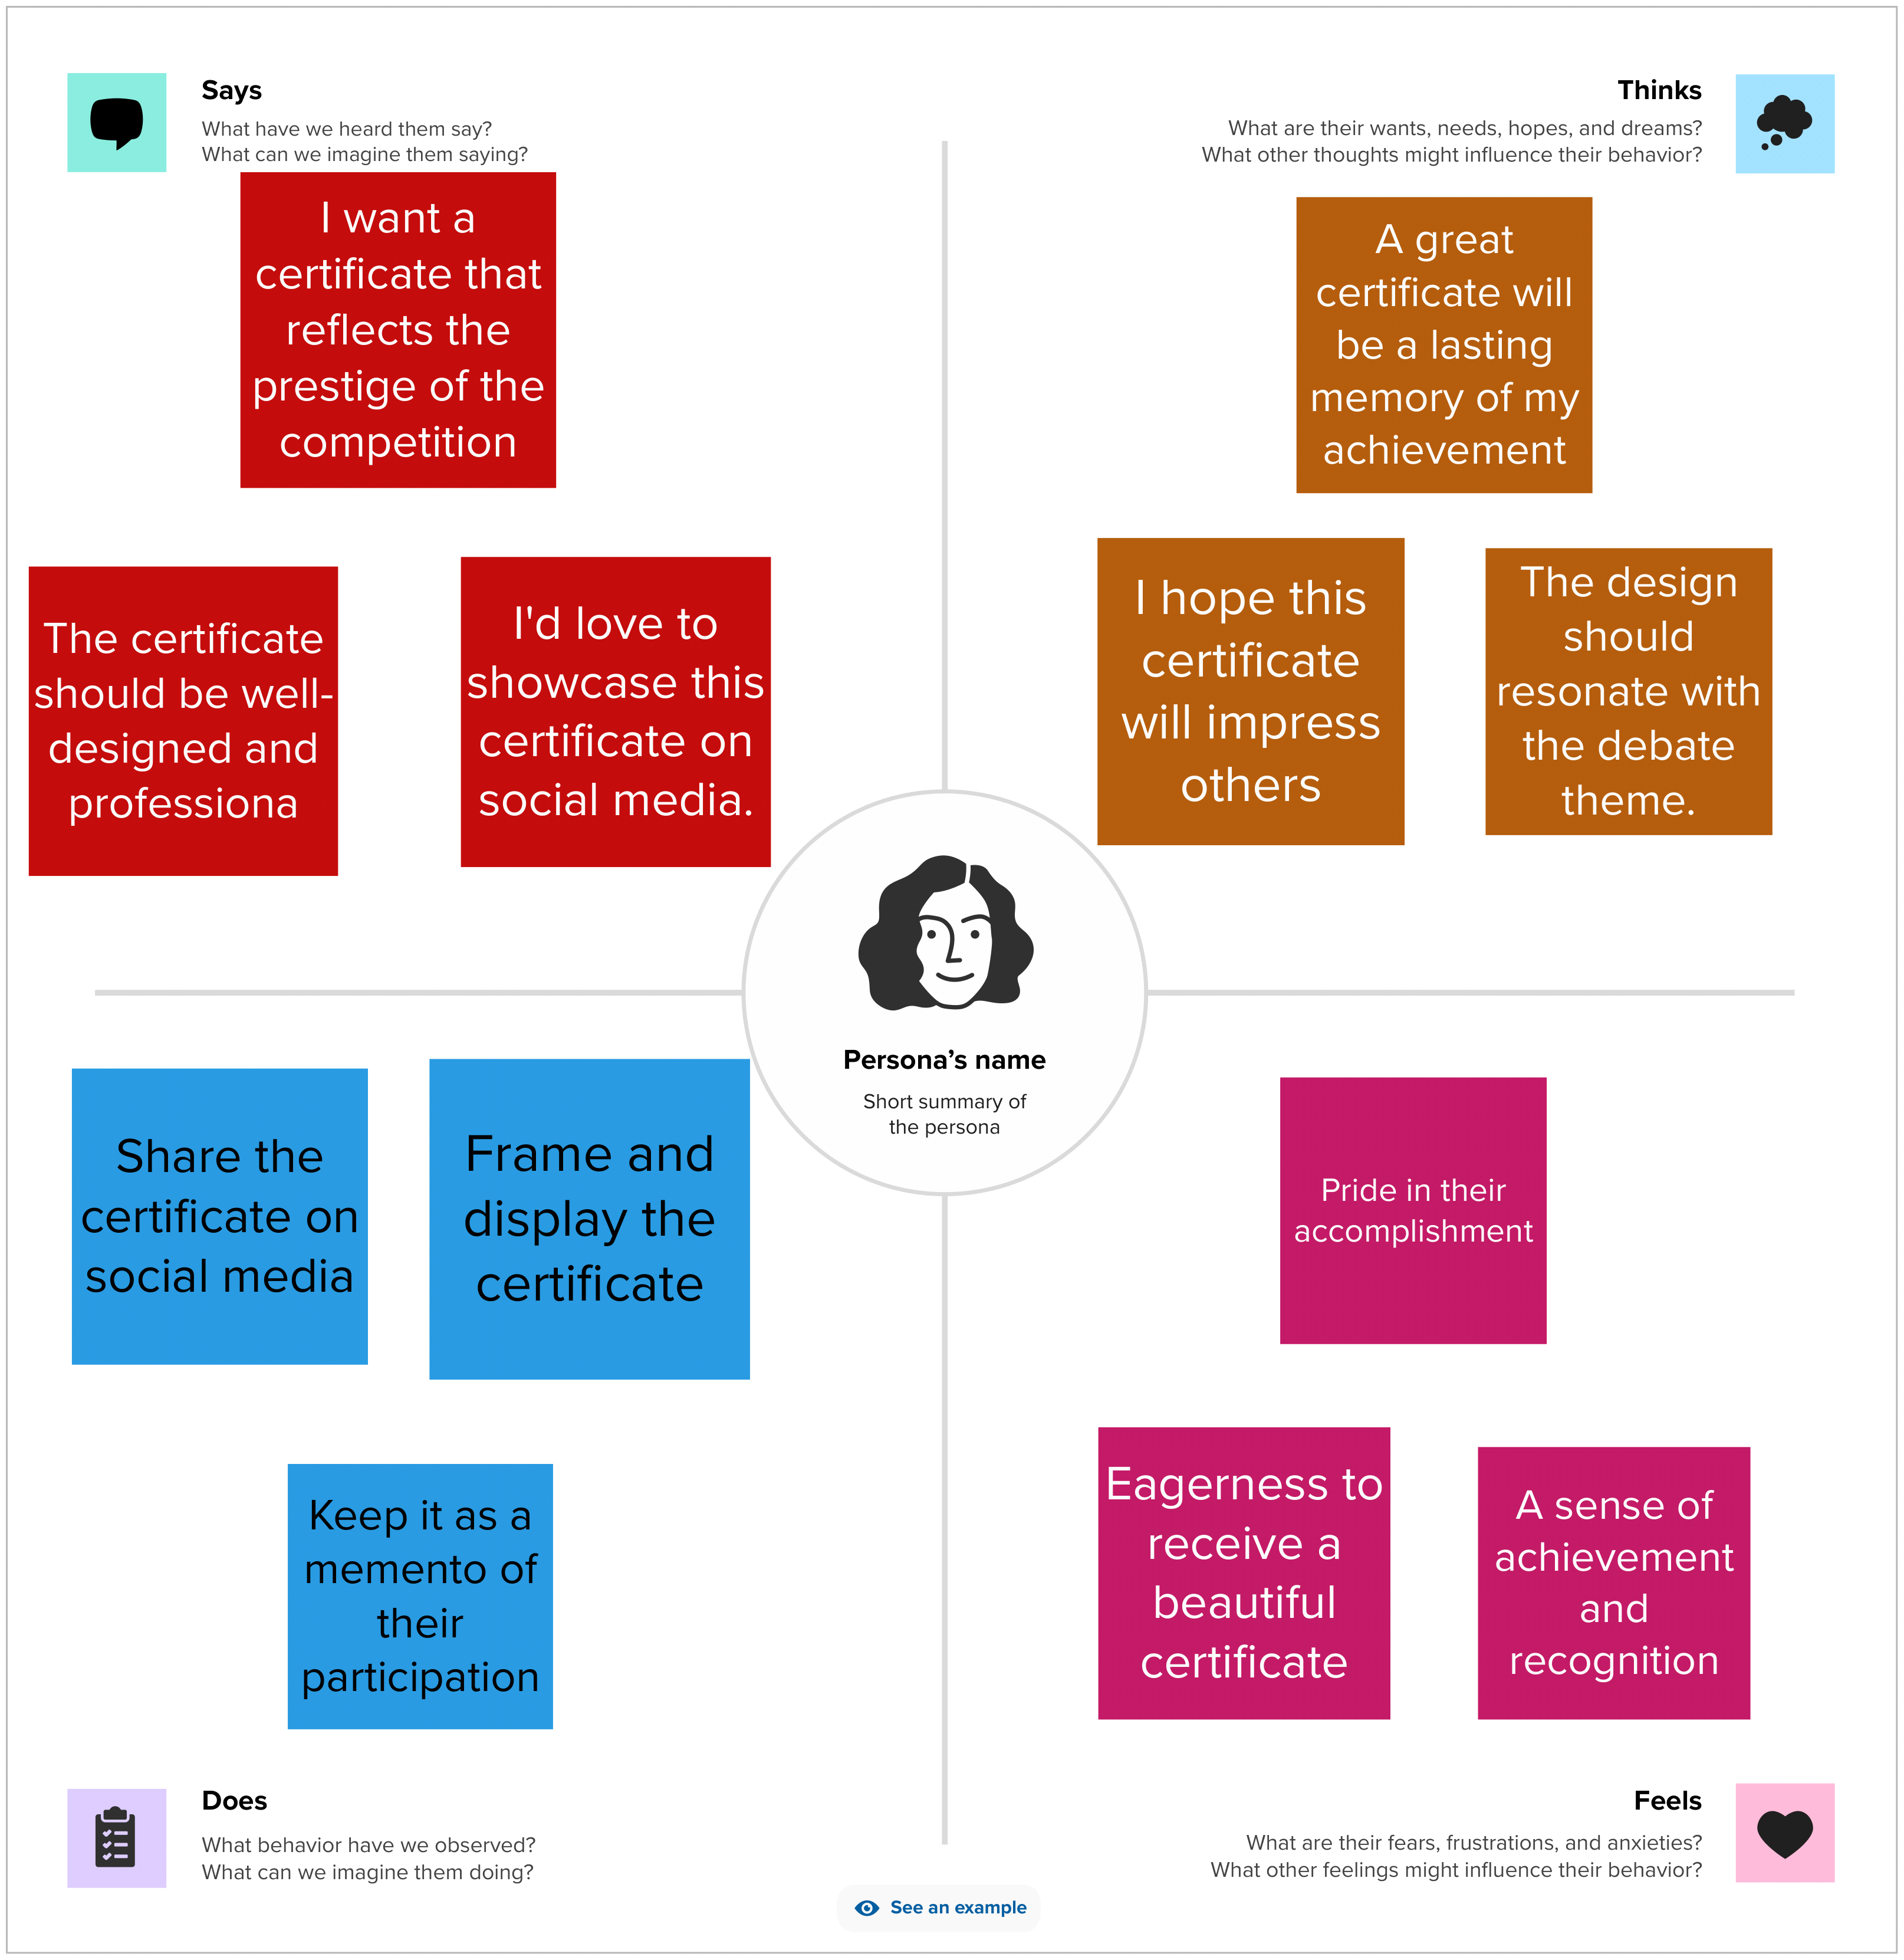

**2.2 IDEATION & BRAINSTORMING**



**RESULT**

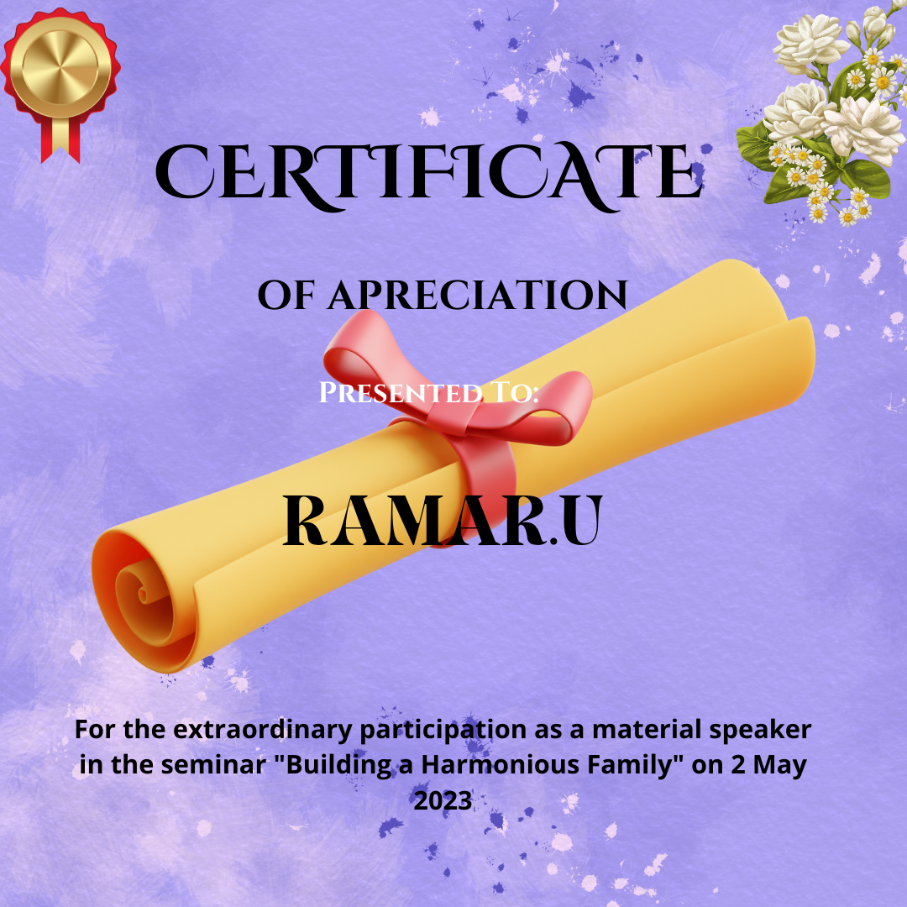

**5. Applications**

Discuss how the certificate will be used in the debate competition, such as awards, recognition, and digital distribution.

**6. Conclusion**

Summarize the project, its significance, and the impact on the debate competition.

**7. Future Scope**

Outline potential improvements or future projects related to certificate design and other visual materials.

**8. Appendix.**

Include any supplementary materials, drafts, or reference images used during the design process.